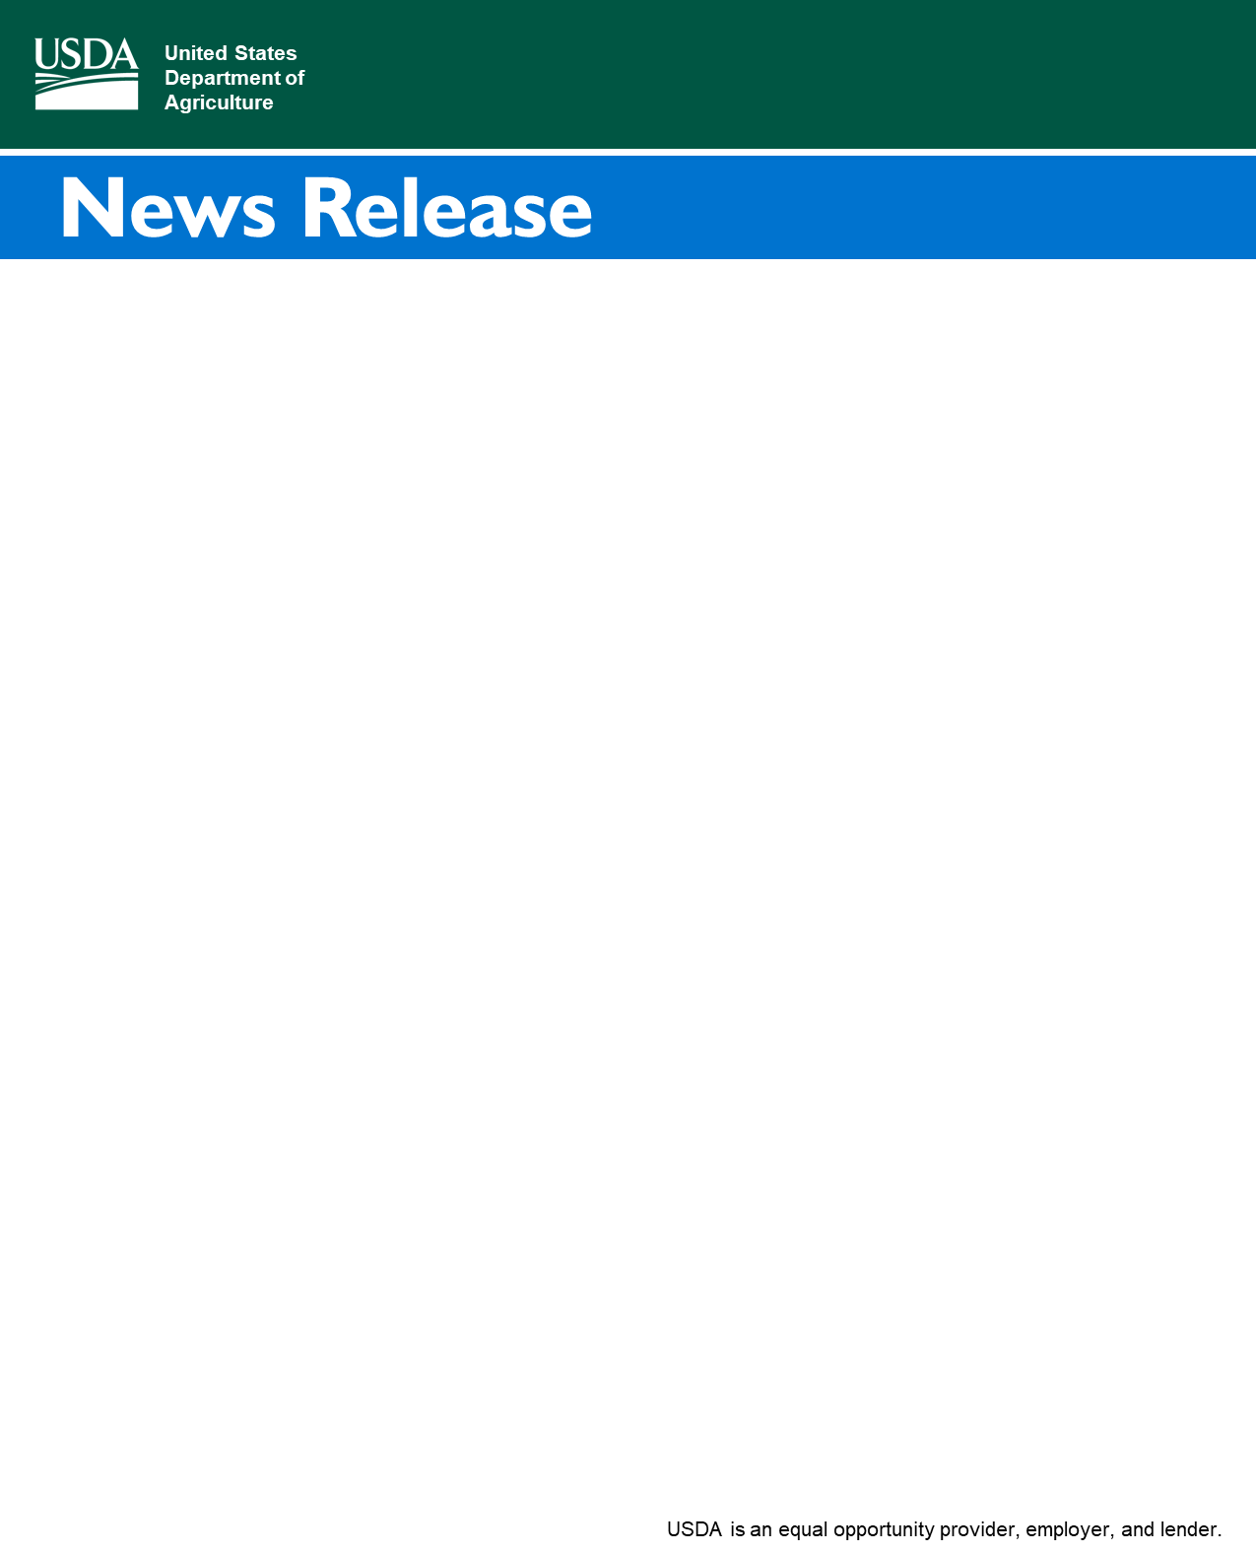

Farm Service Agency

1606 Santa Rosa Road, Suite 138 Richmond, Virginia 23229

City, State ZIP 13

Contact:

Diane Lenoir-Giles

[diane.lenoir-giles@usda.gov](mailto:diane.lenoir-giles@usda.gov)

Rebecca Jones

[rebecca.jones@dcr.virginia.gov](mailto:rebecca.jones@dcr.virginia.gov)

**Expanded Funding Allows Virginia Farmers to Establish Buffers and Wetland Restoration Projects at No Cost**

**RICHMOND, VIRGINIA, July 21, 2022** – The U.S. Department of Agriculture (USDA) Farm Service Agency’s (FSA) Conservation Reserve Enhancement Program (CREP) is funded at a record high in this year’s budget and Virginia farmers can now implement buffers and wetland restoration at no cost.

CREP is a partnership between the FSA and the Commonwealth of Virginia that aims to improve water quality and wildlife habitat. It offers financial incentives, cost-share, and rental payments to farmers and landowners who voluntarily implement riparian forest buffers, grass and shrub buffers, and wetland restoration.

“There has never been a better time for producers to participate in CREP,” said Dr. Ronald M. Howell, Jr., FSA State Executive Director in Virginia. “It costs nothing for farmers to participate in this program now, which will provide their farms with ongoing revenue and other financial benefits. At the same time, the CREP practices promote richer, more fertile farmland and healthier livestock. It is a true win-win.”

Previously, farmers had to cover a portion of the initial cost of establishing buffers and associated infrastructure, such as fencing and livestock watering systems, to enroll in CREP. This year, FSA and the state will pay 100% of eligible practice installation costs, including fencing and alternative watering systems. CREP will also continue to provide incentives and rental payments as well as other on-farm benefits for years to come.

“It’s important to remember that CREP practices can also help make farms more efficient and therefore more profitable,” said Darryl Glover, Virginia Department of Conservation and Recreation Deputy Director. “By removing poorly drained land from cultivation and reducing soil loss into adjacent streams, CREP practices can make farmers’ efforts and resources go further while also improving water quality.”

The CREP contract period is 10-15 years. Enrollment can take place year-round as signups are ongoing.

Interested farmers can reach out to their local [USDA Farm Service Center](https://offices.sc.egov.usda.gov/locator/app?state=us&agency=fsa) to determine eligibility and apply.

USDA touches the lives of all Americans each day in so many positive ways. Under the Biden-Harris Administration, USDA is transforming America’s food system with a greater focus on more resilient local and regional food production, fairer markets for all producers, ensuring access to safe, healthy and nutritious food in all communities, building new markets and streams of income for farmers and producers using climate smart food and forestry practices, making historic investments in infrastructure and clean energy capabilities in rural America, and committing to equity across the Department by removing systemic barriers and building a workforce more representative of America. To learn more, visit [usda.gov](https://www.usda.gov)*.*

#

*USDA is an equal opportunity provider, employer and lender.*